
Submitted by : Spogmai Jan
Roll no : 2430 -0081
Submitted to : sir nouman asim

Computer networks lab 06
TASK 01:
Design a network using one switches connected via a wired. Connect 5 PCs to the switch and a DHCP server. Configure the server apply Dynamic Configuration Protocol, No manual/Static implication of IPs for systems.
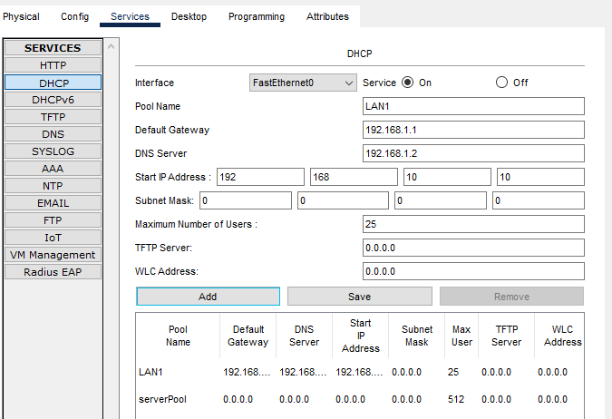
PC 0:
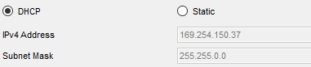
PC 01:
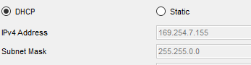
PC 02:
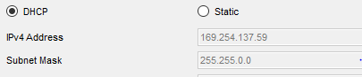
PC 03:
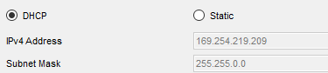
PC 04:
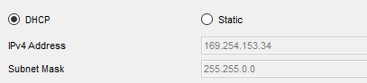

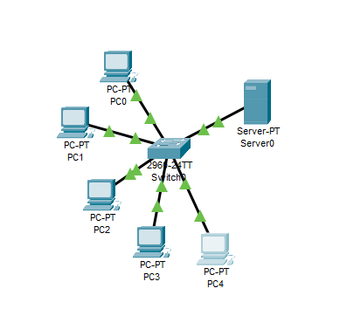

TASK 02: Create a network in which you have three systems connected via same network. Switch one is also connected to DHCS, DNS and Web servers. You need to configure how we can get data from a website which is hosted on a Web server and Configure the server apply Dynamic Configuration Protocol(DHCP), no Static implication of IPs for systems. A website cs.com is hosted on the Web Server which is made to access from the PC0 or PC1 or PC2.which display “BSCS F24”. This should be done by properly creating a route from the PC’s to Server. DNS server should be configured. Also get the reply from PC0 to PC1, PC2 by using name not the ip address.

DHCP:
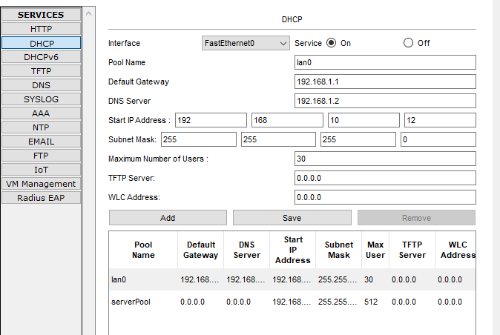
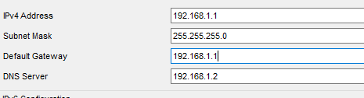

DNS :
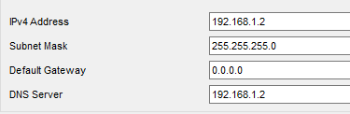
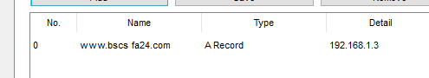

Web server:
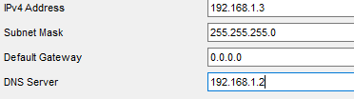

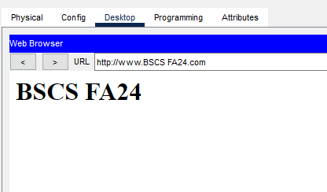
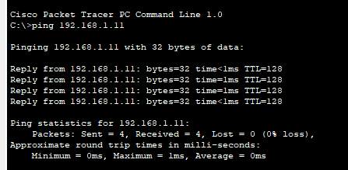

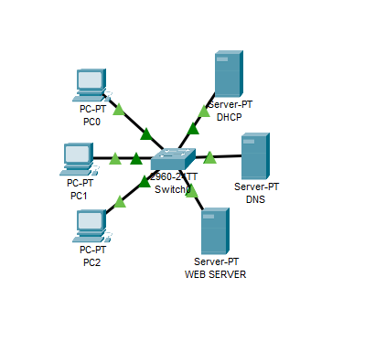
TASK 03:
Design a network using 1 routers, 2 switches, and Switch 1 have LAN A and Switch
2 have LAN B. In LAN A, Switch 1 have DHCP, DNS and web server along with
two PC’s. In LAN B Switch 2 have three systems and get the IP by applying
Dynamic Configuration Protocol, no Static implication of IPs for systems. .
These switches are connected through a router and a website case.com is hosted on
the Web Server in LAN A which is made to access from the LAN B PC1 which
display “Hello Students”.

Router CLI
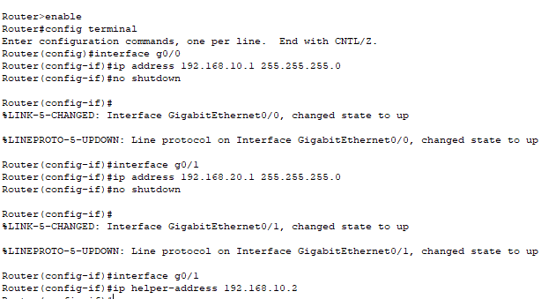
DHCP:
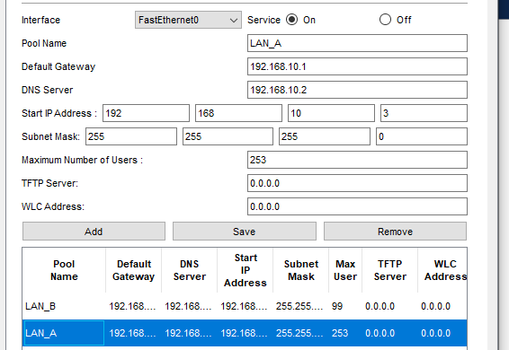

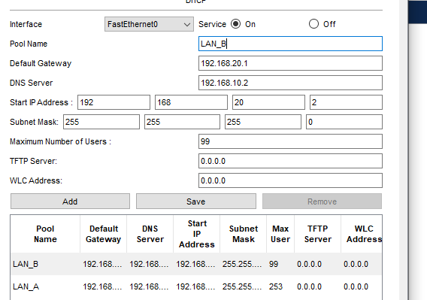

Web SERVER:
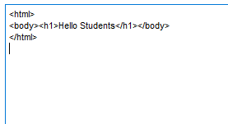
LAN-A PCS:
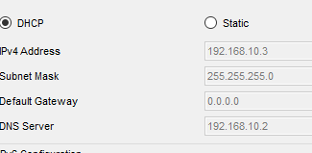
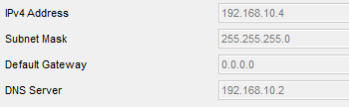

LAN-B PCs:
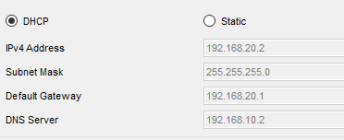
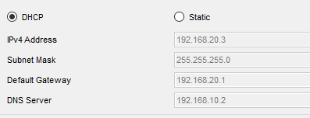
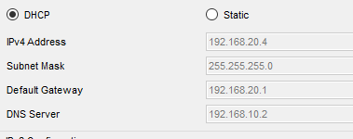
LAN-B PC-1



